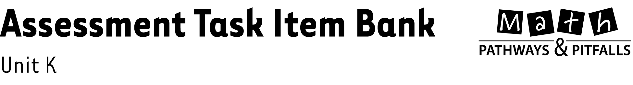

What Is in This Document?
This document contains one assessment task item per lesson for Unit K. Use these items as an item bank to create your own customized assessment tasks correlated to the lessons that you plan to teach.

How To Make a Customized Assessment Task
Learn how to make a customized assessment task by referring to the Assess How-To file in the K-1 Assessments folder. The instructions are easy, requiring you to simply select, drag, and drop each item onto an Assess Template, which is also found in the K-1 Assessments folder. Use items from the Assessment Task Item Bank, or type in your own problems. To facilitate this process, each item is labeled with the correlated unit and lesson number.

