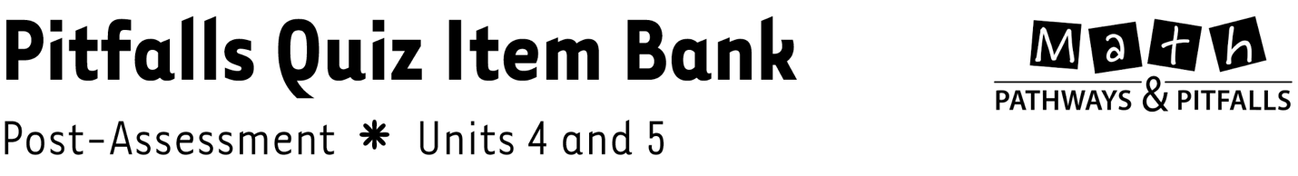

What Is in This Document?
The following pages contain one post-assessment quiz item per lesson for Units 4 and 5. Use these items to create your own customized quiz correlated to the lessons that you taught from each unit.
Unit 4 Post-Assessment Pitfalls Quiz Item Bank and Answer Key
Unit 5 Post-Assessment Pitfalls Quiz Item Bank and Answer Key

How to Make a Customized Pitfalls Quiz
Learn how to make a customized Pitfalls Quiz by referring to the Quiz How-To file in the Pitfalls Quizzes Folder. The instructions are easy, requiring you to simply select, drag, and drop each item onto a Quiz Template, which is also found in the Pitfalls Quizzes Folder. Use items from either or both units to make your customized quiz, or type in your own problems. To facilitate this process, each item is labeled with the correlated unit and lesson number.
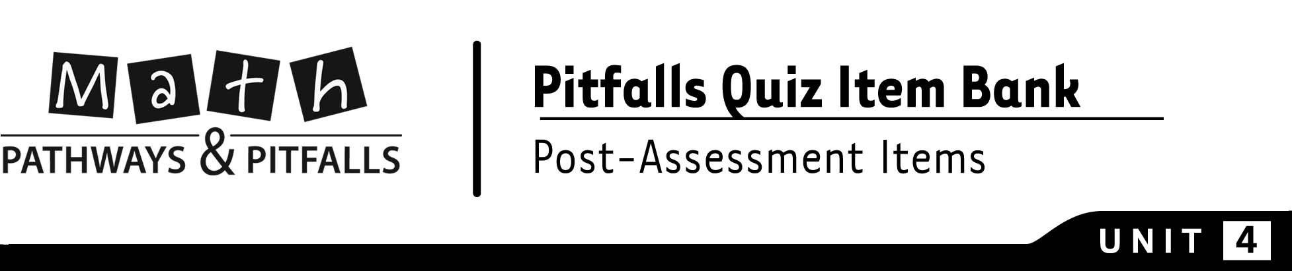
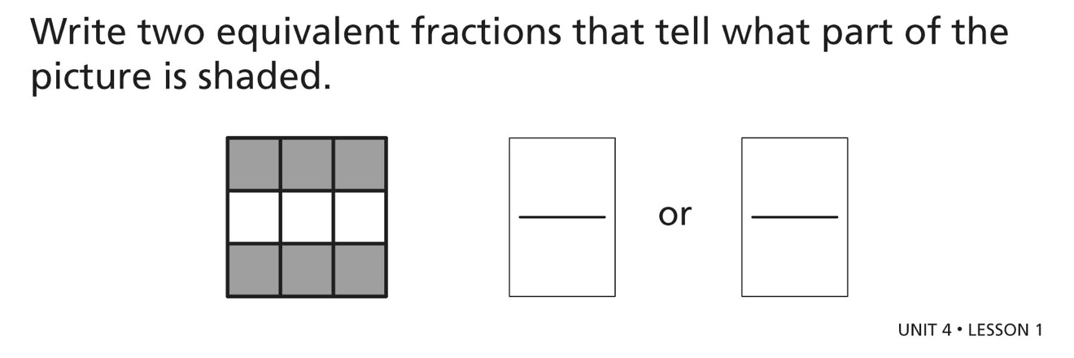
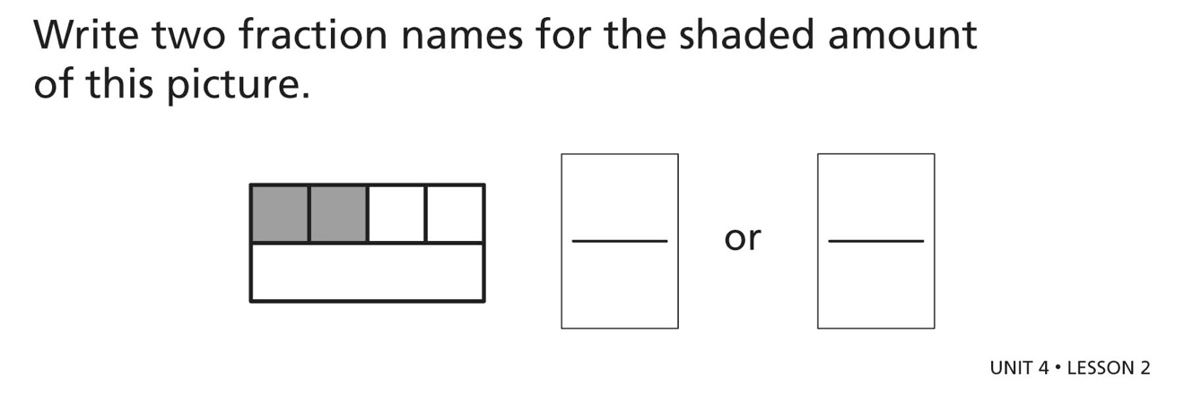
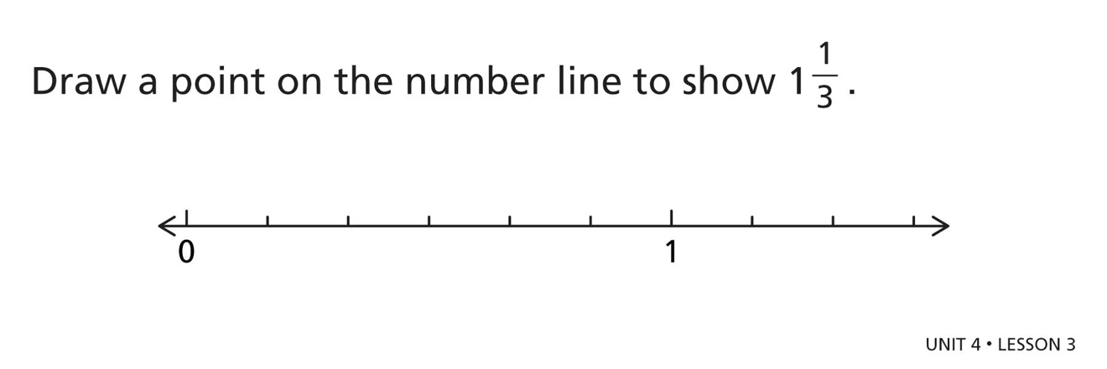
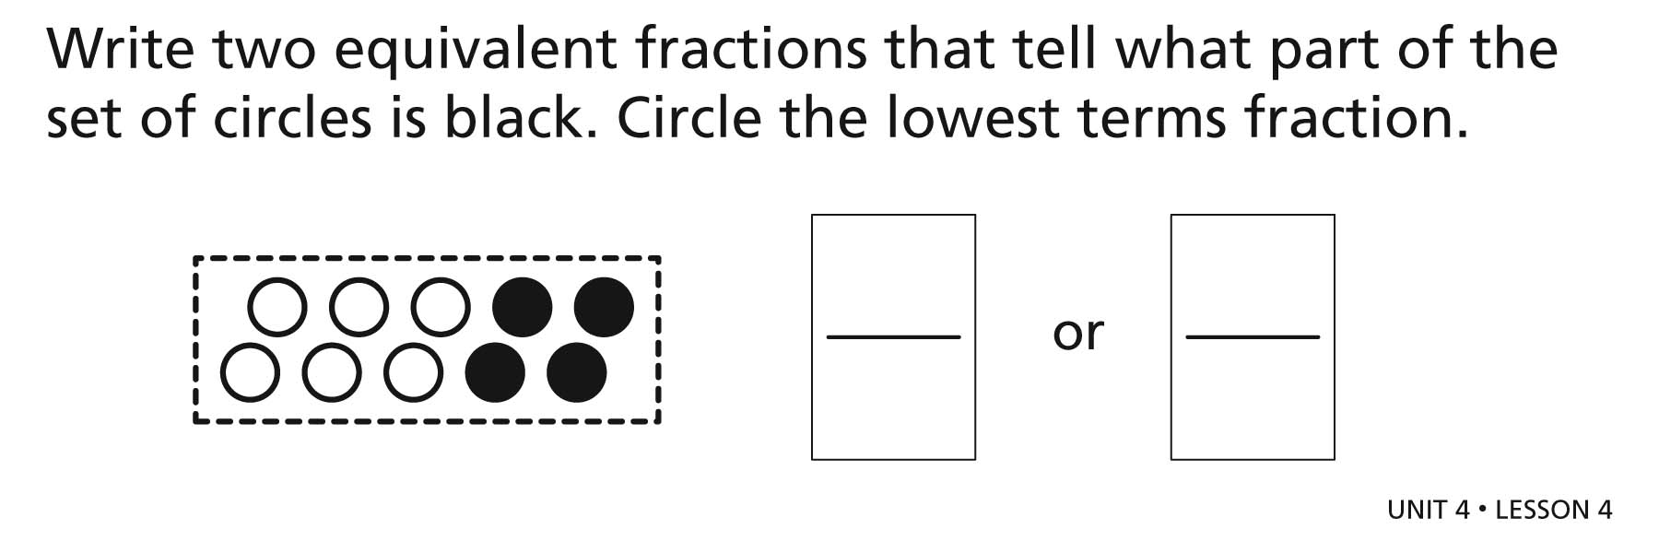
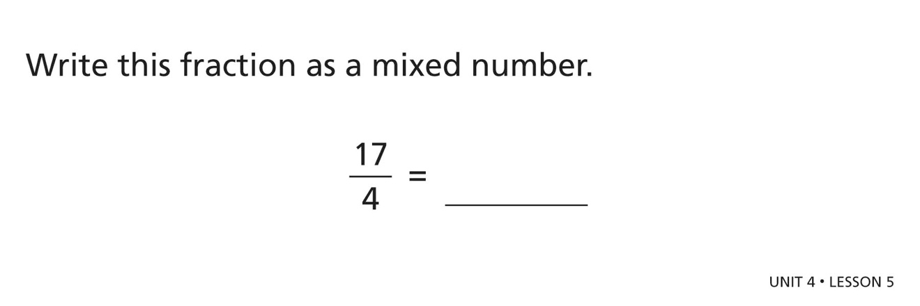
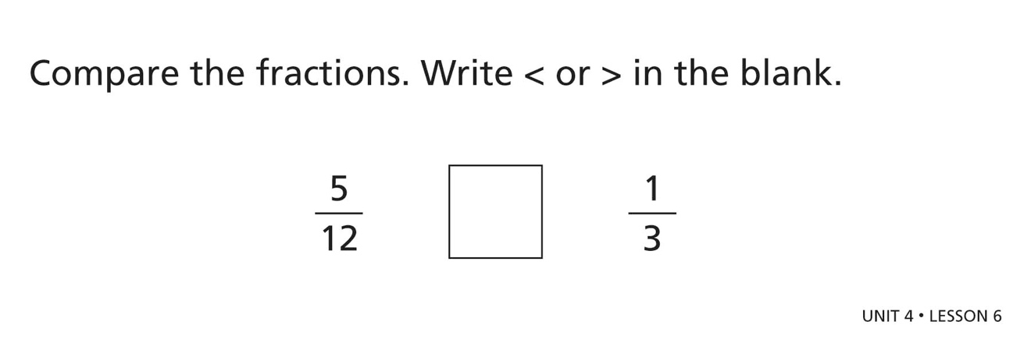
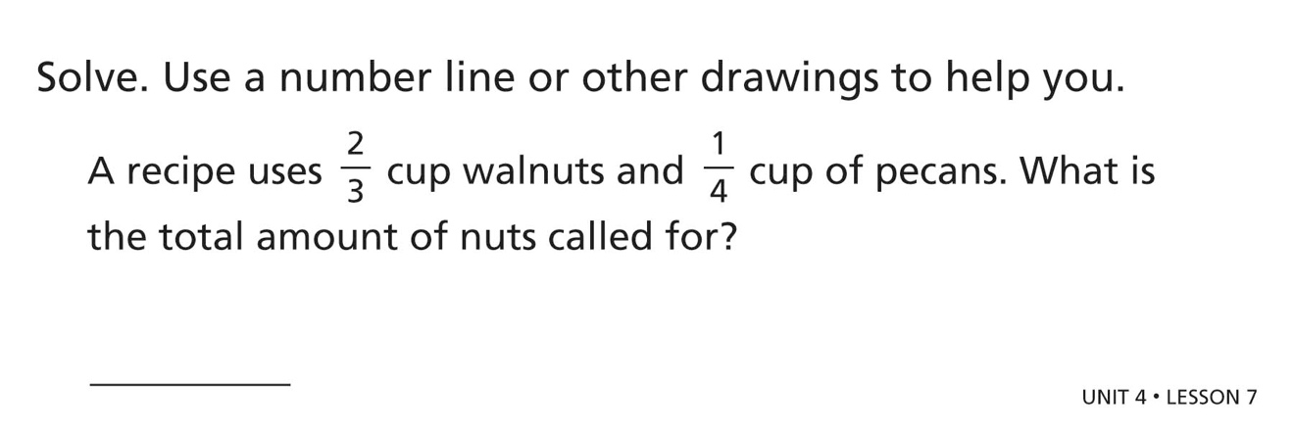
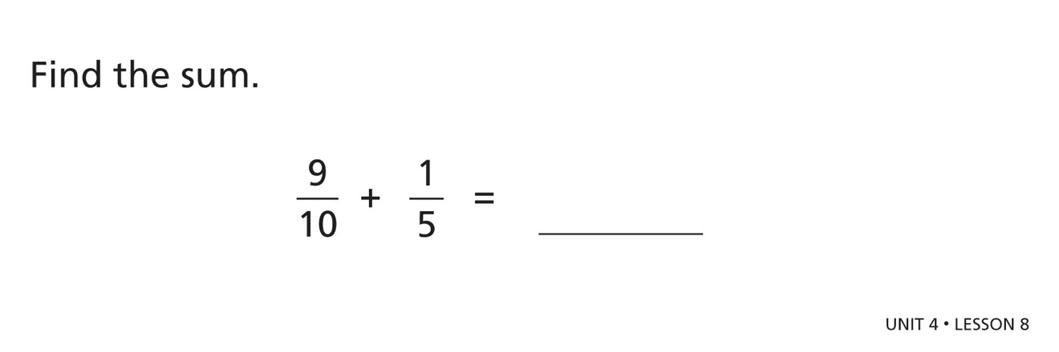
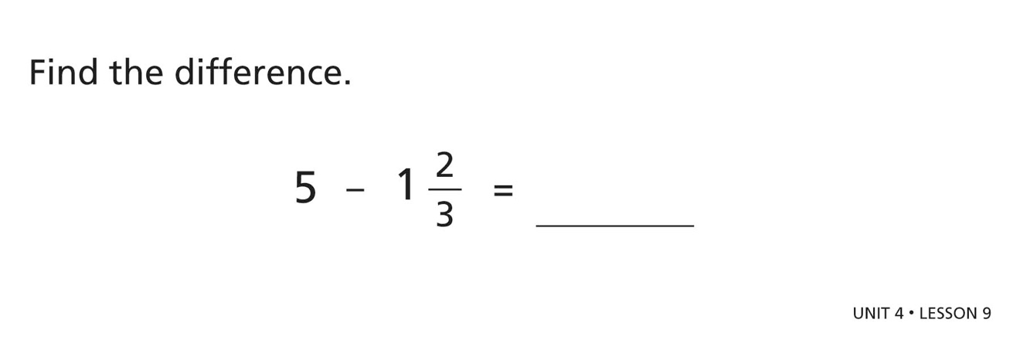
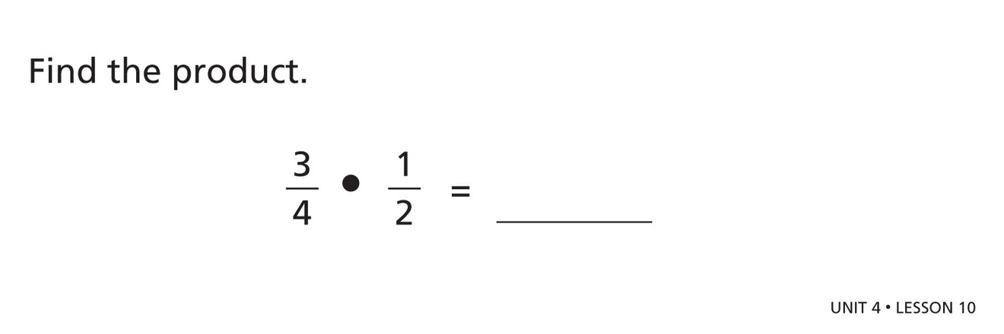
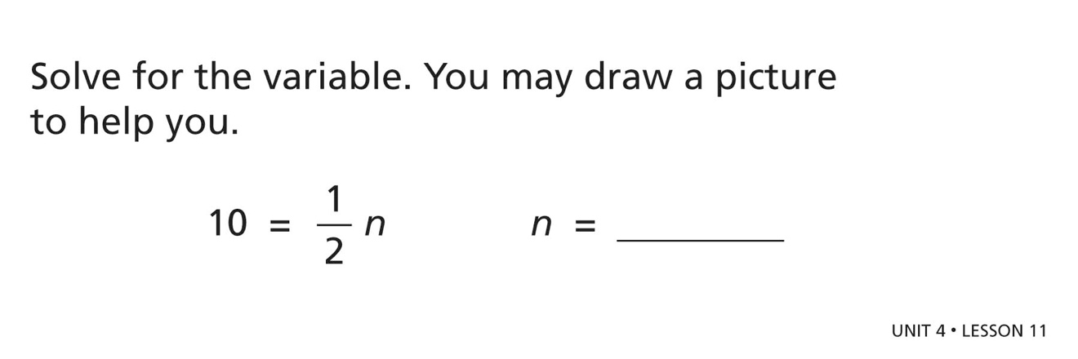

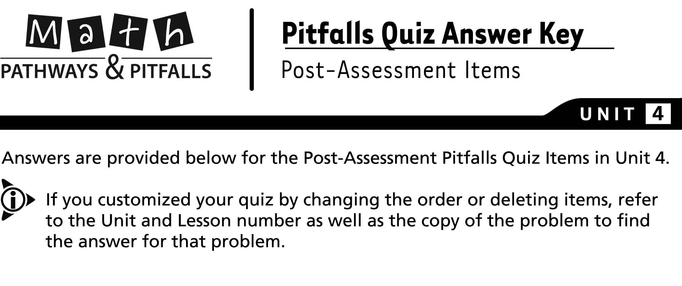
Default # | Unit | Lesson | Problem | Answer
 | 4 | 1 | 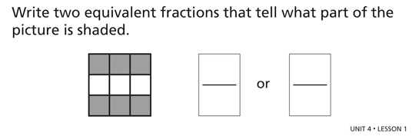 | or
 | 4 | 2 | 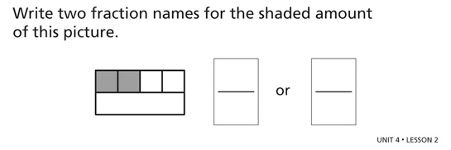 | or
 | 4 | 3 | 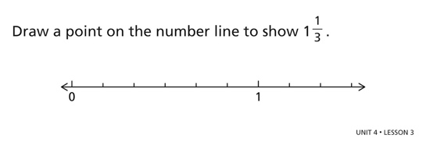
 | 4 | 4 | 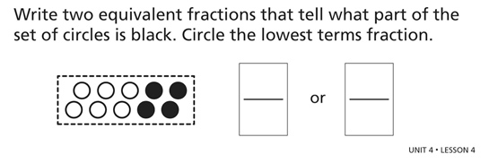 | 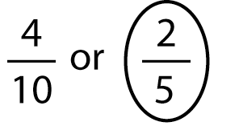
 | 4 | 5 | 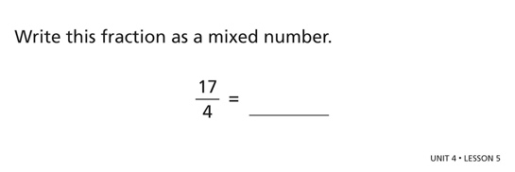
 | 4 | 6 | 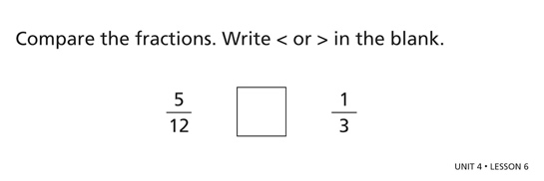 | >
 | 4 | 7 | 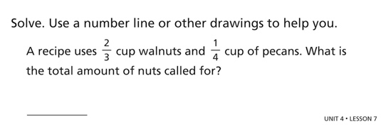 | cup
 | 4 | 8 | 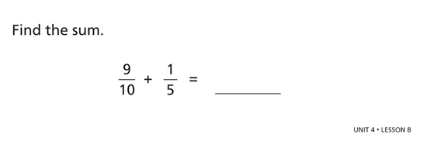
 | 4 | 9 | 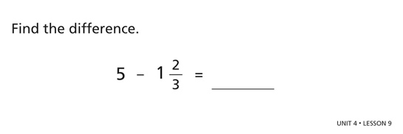
 | 4 | 10 | 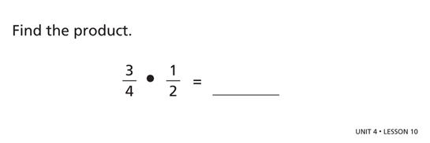
 | 4 | 11 | 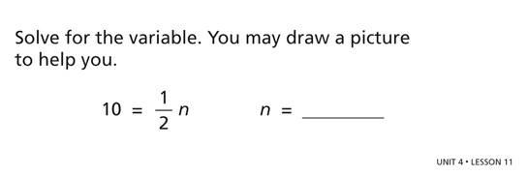 | 20

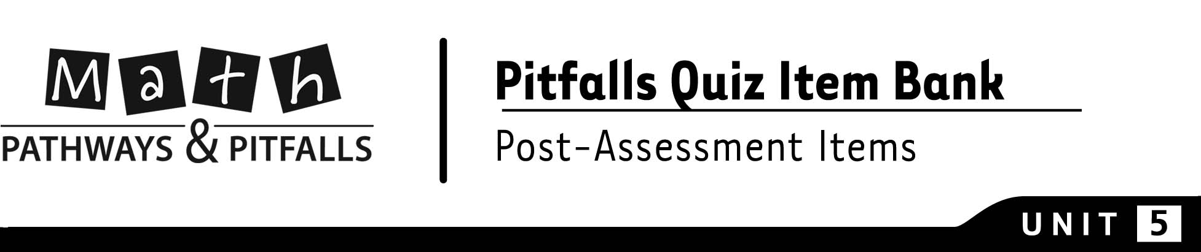
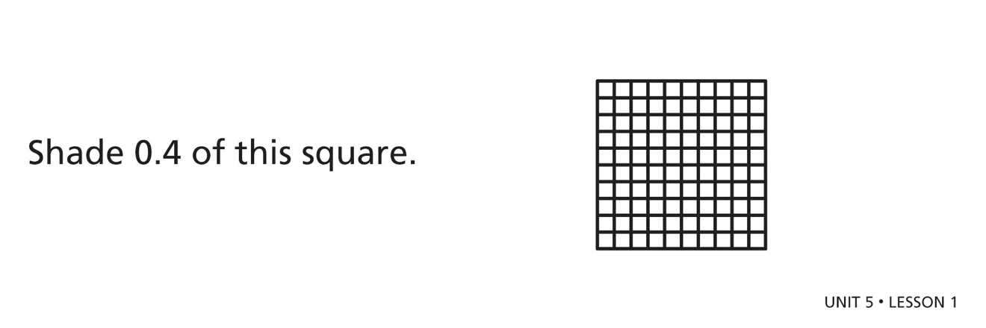
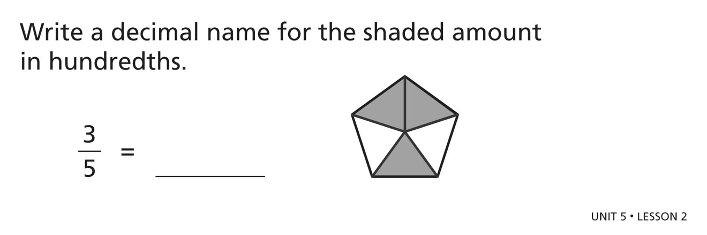
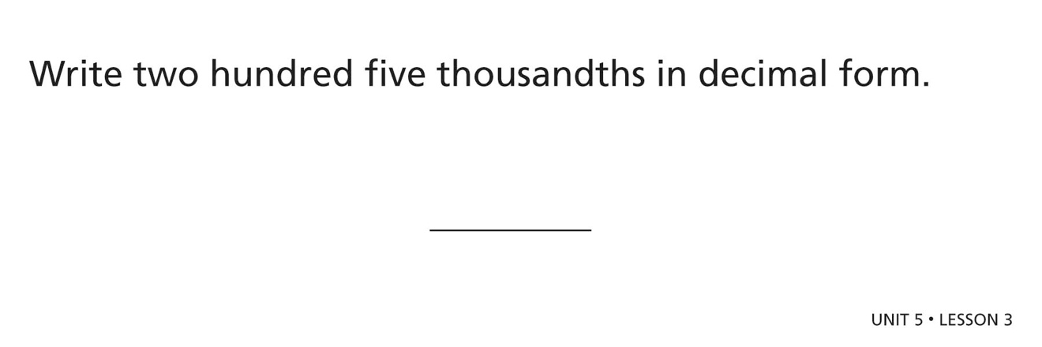
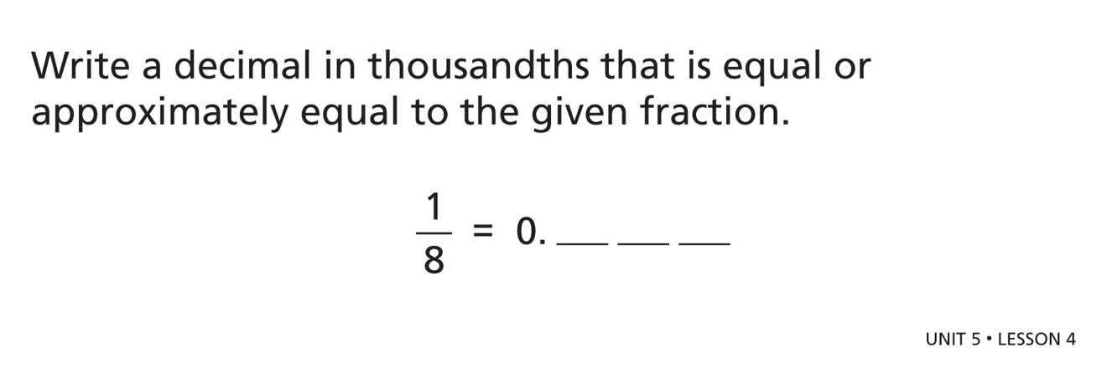
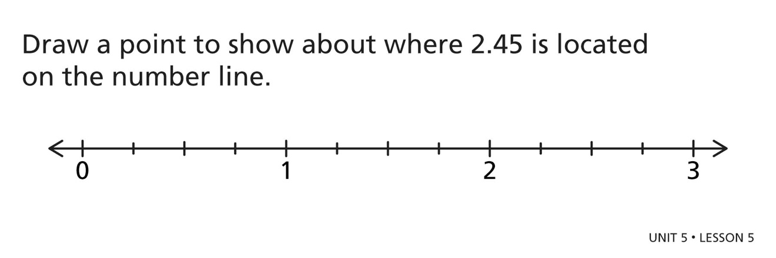
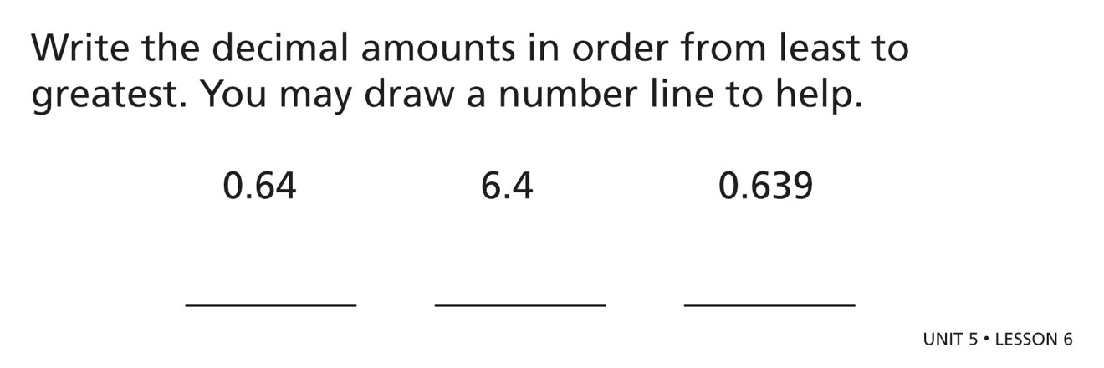
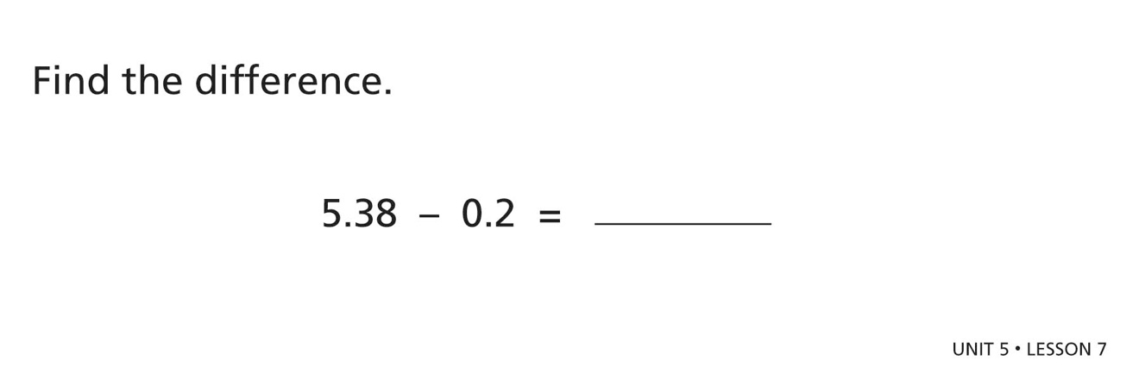
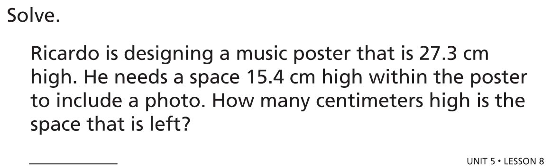
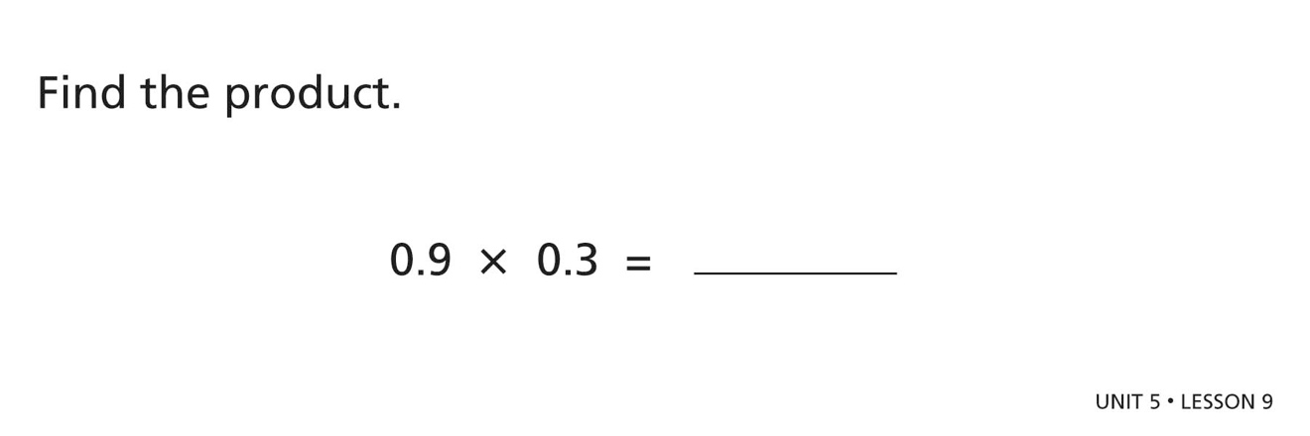
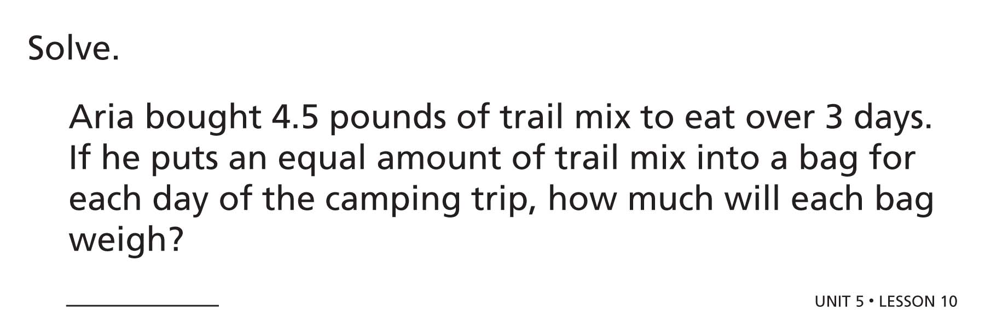
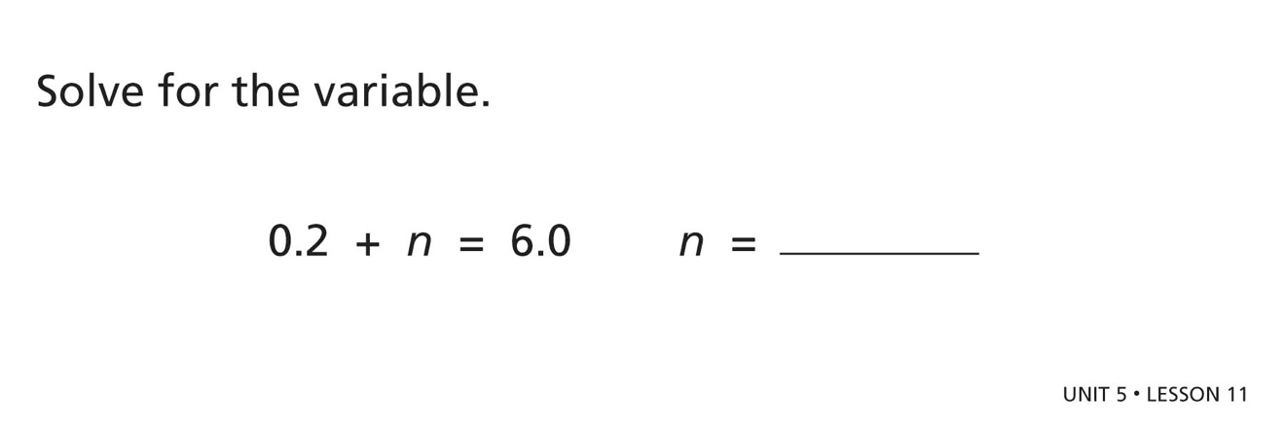

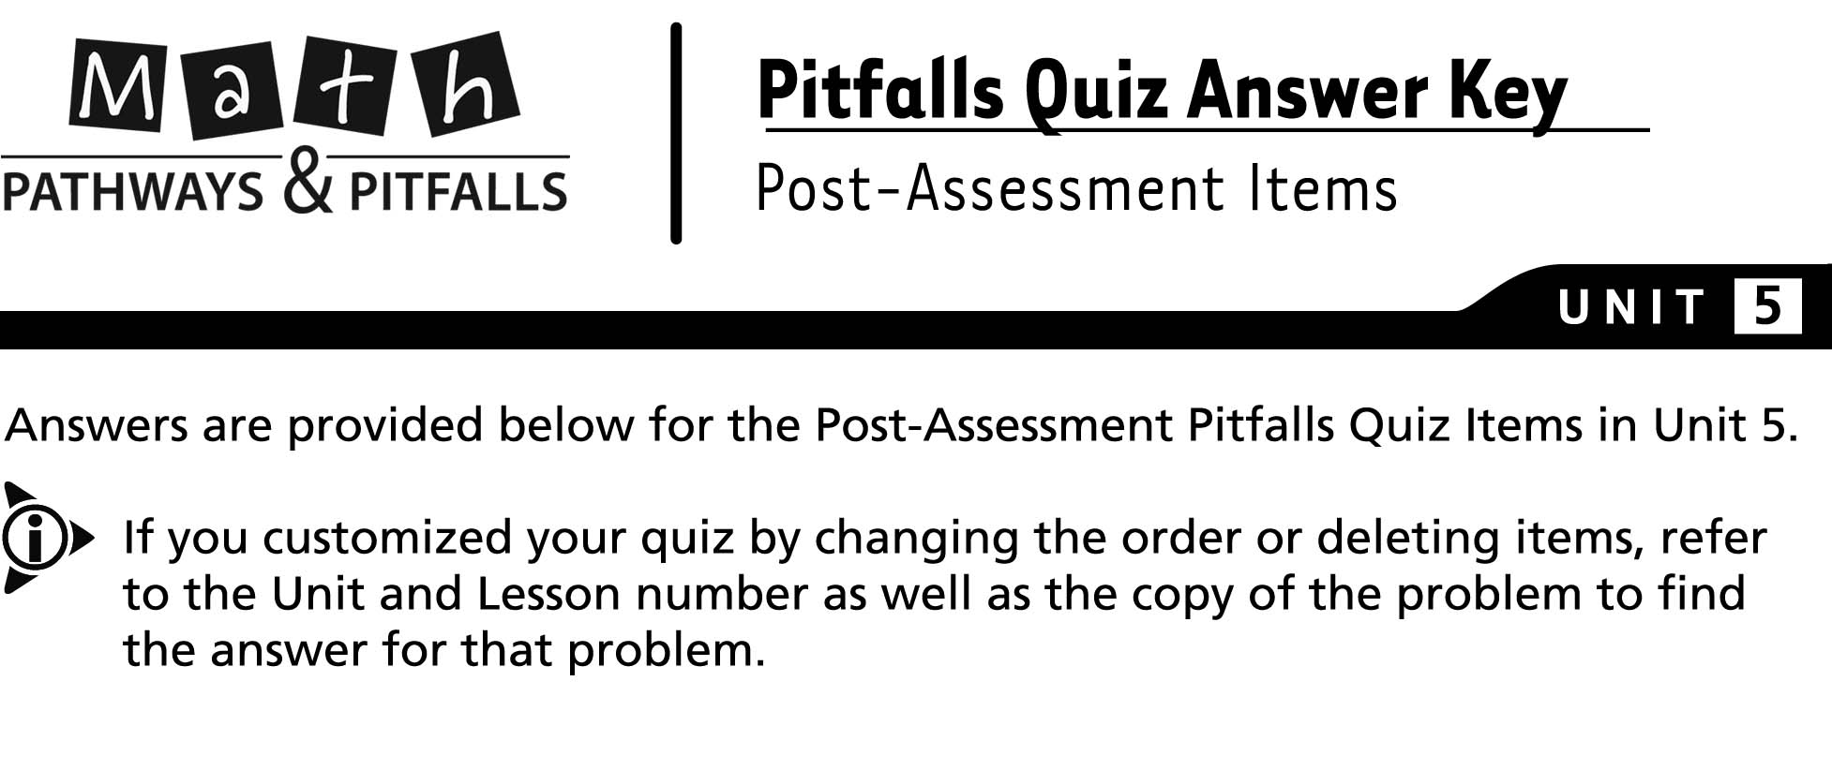
Default # | Unit | Lesson | Problem | Answer
 | 5 | 1 | 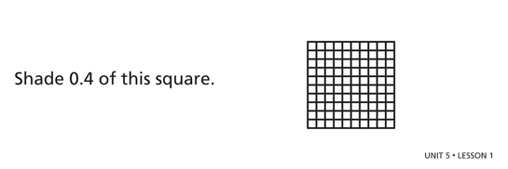 | Shade any 4 tenths  (40 hundredths).
 | 5 | 2 | 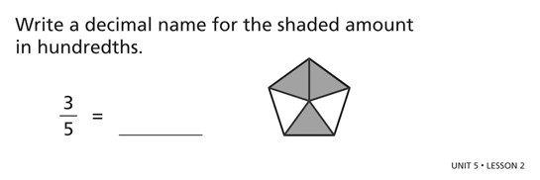 | 0.6
 | 5 | 3 | 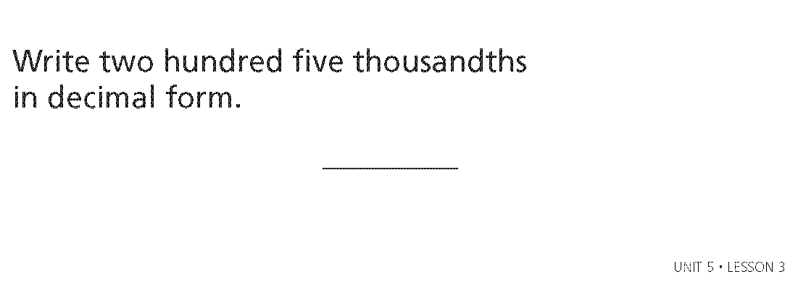 | 0.205
 | 5 | 4 | 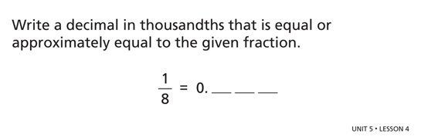 | 0.125
 | 5 | 5 | 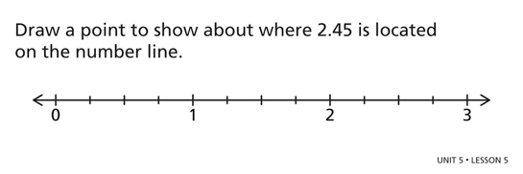
 | 5 | 6 | 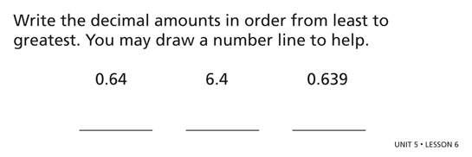 | 0.639 0.64 6.4
 | 5 | 7 | 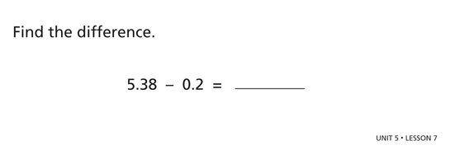 | 5.18
 | 5 | 8 | 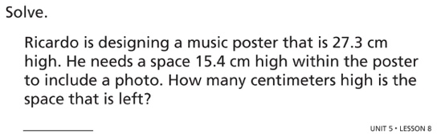 | 11.9 cm
 | 5 | 9 | 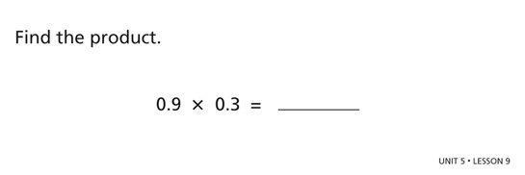 | 0.27
 | 5 | 10 | 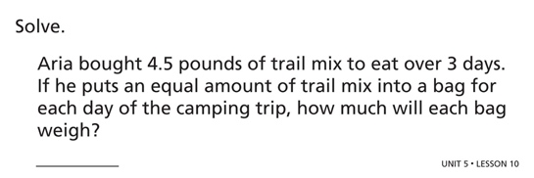 | 1.5 pounds
 | 5 | 11 | 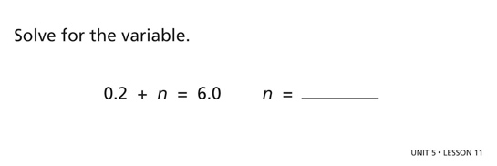 | 5.8

